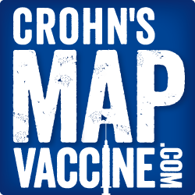
Phase 1 trial complete!
Please help us as we enter phase 2.

