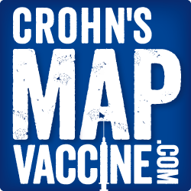

Phase 1 trial is now complete. Your change will help us through phase 2.
Find us on Facebook and Twitter
www.crohnsmapvaccine.com

